FAMILY FIRST
Product Walkthrough
Current prototype capabilities, limitations, and measured results
Prepared by Ian Taylor for Tom Landino & Brian DeLorge
13 August 2026 · Research prototype · All three safety categories remain research-only
Purpose. This briefing shows the current Family First research prototype screen by screen and ties each claim to the simulator run listed in the appendix.
Evidence boundary. The prototype demonstrates user experience, privacy boundaries, processing flow, and measured execution speed. Detection accuracy, guardian delivery, and physical-device readiness remain unverified.

Overview
Family First is an early iPhone product concept designed to give families a truthful view of the digital-safety support available at any moment. The current prototype validates the product experience, privacy boundaries, and core processing flow. Detection accuracy and production readiness remain unverified.
Coverage display. The interface reports each capability separately. Available, unavailable, and interrupted functions remain visible as individual entries.

What has been demonstrated:
- User-visible status and alerts. The prototype can show the current session state and deliver three content-free alerts on the same device: stopped, interrupted, and restored. The lock-screen example in Section 2 comes from the simulator run listed in the appendix. Guardian delivery is disabled.
- On-device AI research measurement. Apple's on-device model completed 20 structured test calls in the adult and synthetic research lane. Median response time was 1.01 seconds, and all 20 results matched the required response structure. These results measure technical execution only.
- End-to-end processing with a safe default. The safety pipeline processed the test scenario and returned “status unknown.” Approval for decision thresholds is pending, so no safety state is assigned. No classification-quality claim is made.
Six documented dependencies affect capabilities beyond the current prototype: user-facing copy, evaluation thresholds, data authorization, encryption and recovery design, provider permissions, and physical-device access. Section 6 records each dependency and its owner.

1. Product experience
The prototype includes a Child experience and a Guardian experience. A separate Developer view supports internal testing and is excluded from production builds.

1.1 Simple, truthful session controls
The Child screen shows the exact session state, the time it was observed, and the next valid action. The design uses explicit Start, Pause, and Stop controls because a single on/off switch could show protection before the service was ready.
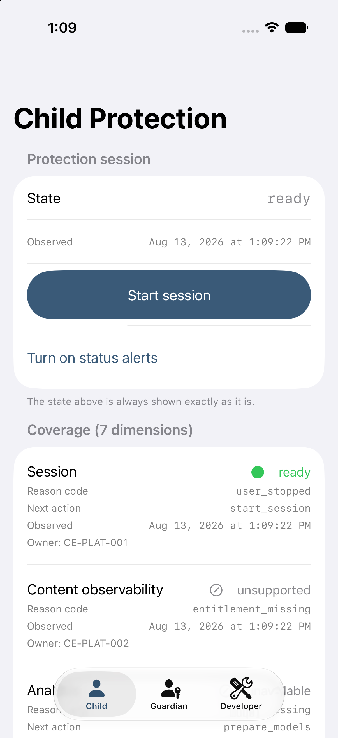  Ready. The screen presents the next valid action. | 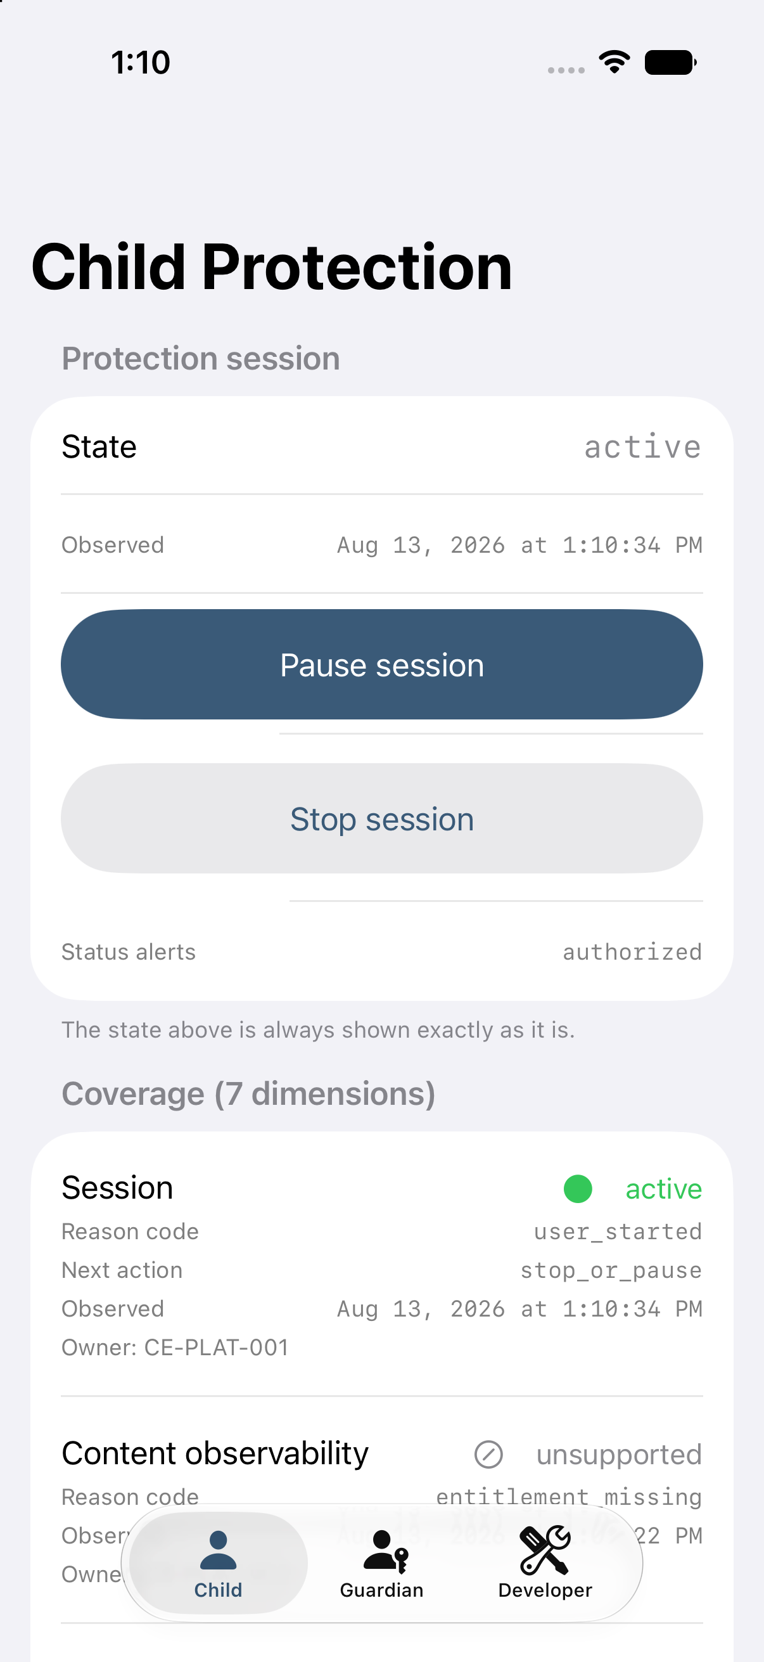  Active. Pause and Stop appear after the user starts a session.
The status-alert control requests notification permission after the user chooses it. The app does not request permission at launch.

1.2 Coverage across seven product capabilities
The dashboard reports seven capabilities separately: session, content visibility, analysis readiness, preview safety, provider connection, guardian delivery, and safety state. Each row shows status, reason, next action, observation time, and accountable team.
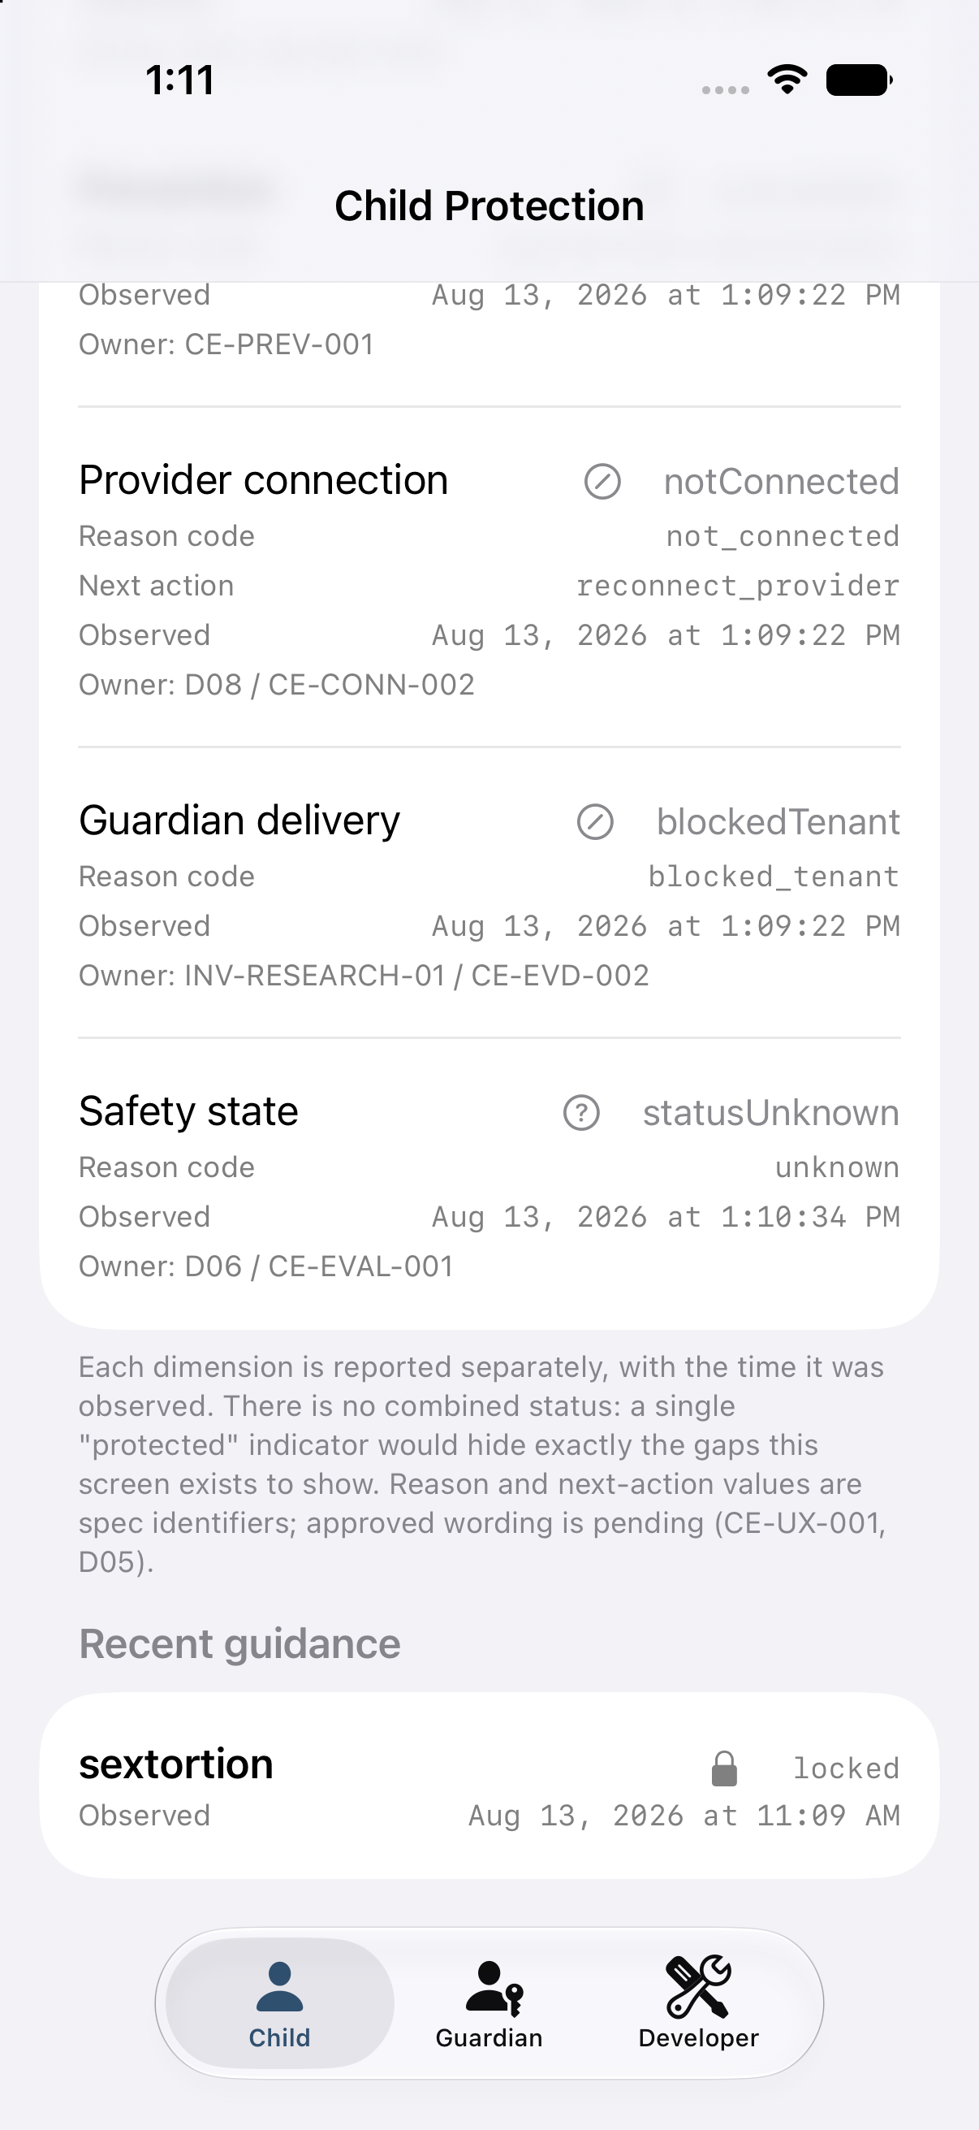
The lower dashboard view shows capability gaps and the action or owner associated with each gap.
Coverage presentation. The interface does not use a single “protected” badge because a combined label could conceal unsupported or interrupted capabilities. Early screens show internal reason codes while safeguarding and legal teams review the final user-facing language.
Starting a session changed one of seven capability rows in this run. The remaining rows stayed unchanged because no new evidence was available for those capabilities.

1.3 Prototype state coverage
The product model defines ten session conditions. The Child screen directly reaches Ready, Active, Paused, and Stopped. Two additional conditions are brief transitions. Four conditions are available only through internal testing and are not yet produced by the application.
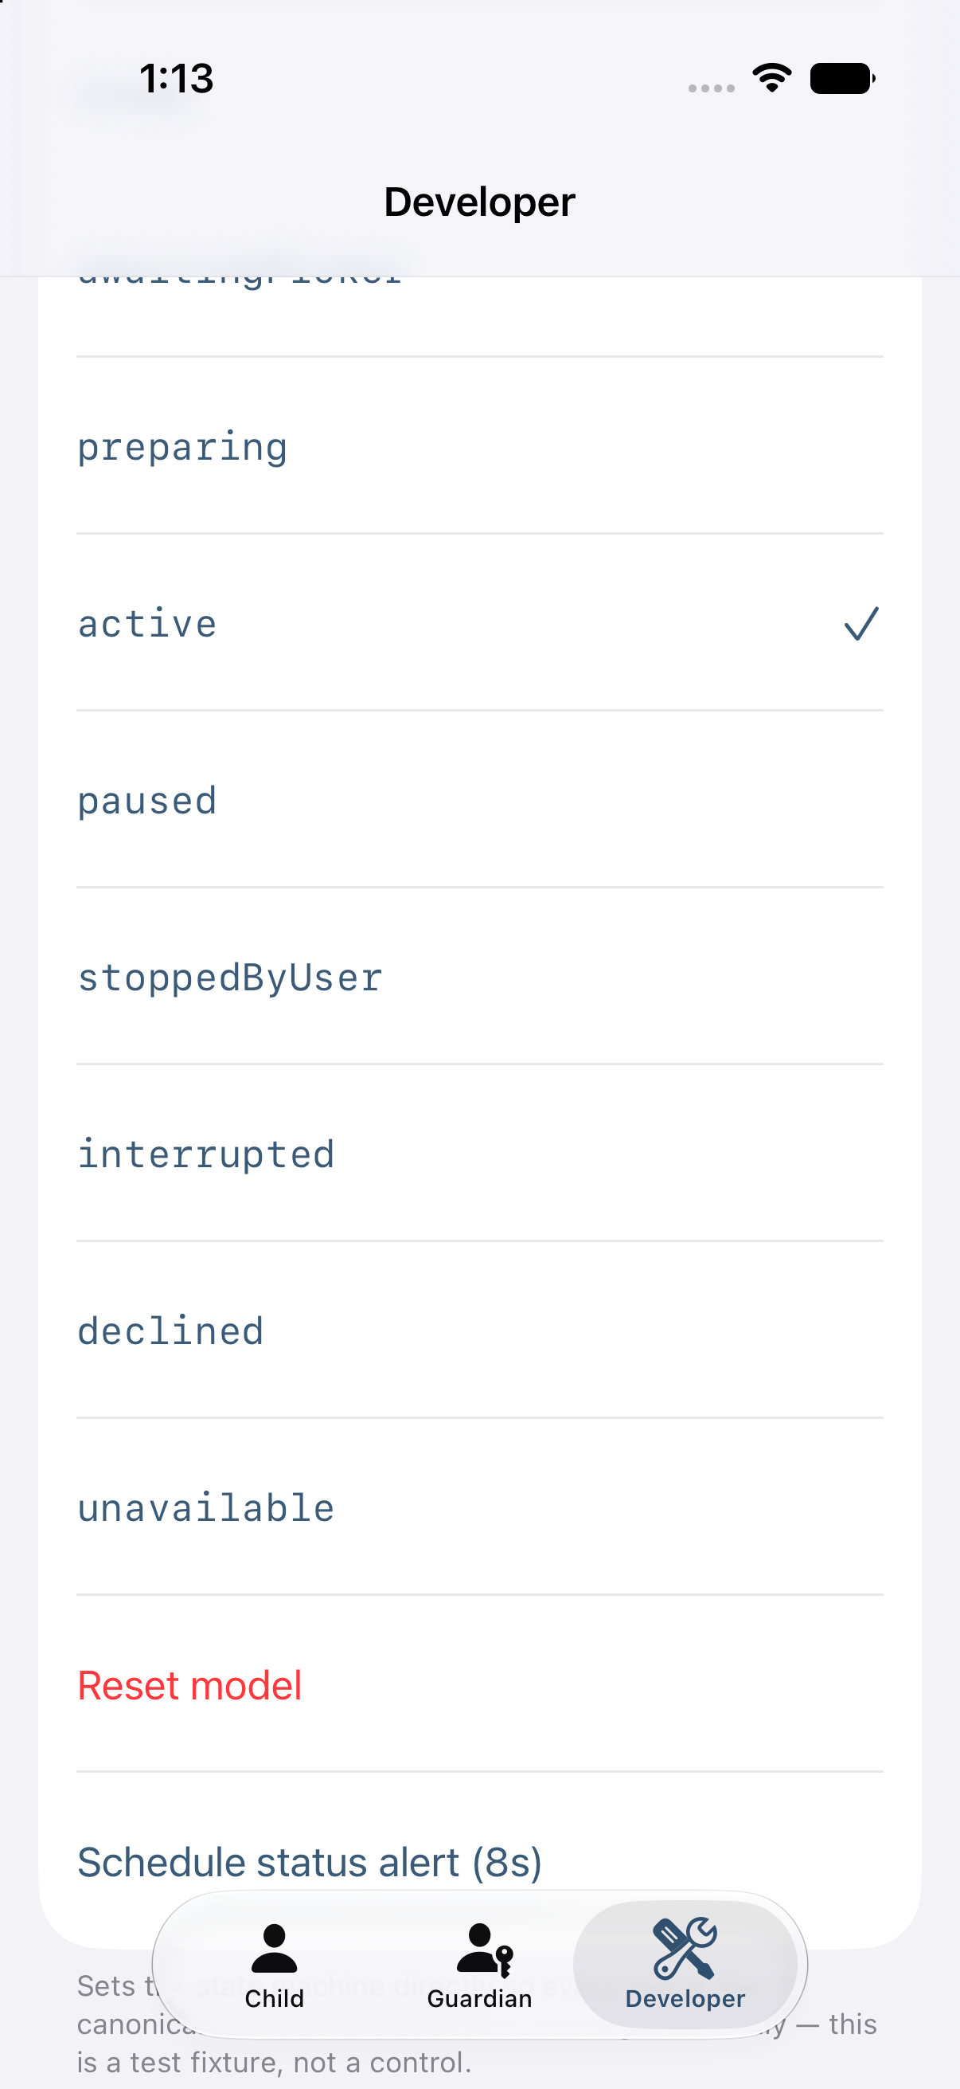  Internal test view used to verify all session conditions. | 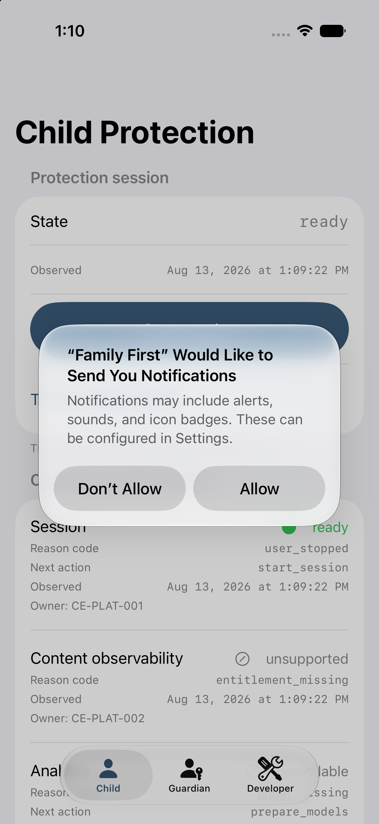  Notification permission appears after the user asks for alerts.

2. Local status alerts
The product specification calls for content-free alerts when protection stops, is interrupted, loses permission, becomes stale, or is restored. This prototype emits Stopped, Interrupted, and Restored alerts.
Alert condition | Current status | Basis or limitation
Stopped | Demonstrated | Triggered by the application session state
Interrupted | Demonstrated | Triggered by the application session state
Restored | Demonstrated | Sent after an interruption resolves; absent at launch
Permission lost | Pending | Requires a relevant permission and a real-time observer (CE-PLAT-002)
Stale | Pending | Requires real-time staleness evaluation (CE-COV-001)

Two alerts remain pending. Permission-lost and stale alerts require real-time monitoring that has not been implemented. The prototype leaves these alerts disabled and makes no detection claim for either condition.

2.1 Lock-screen example
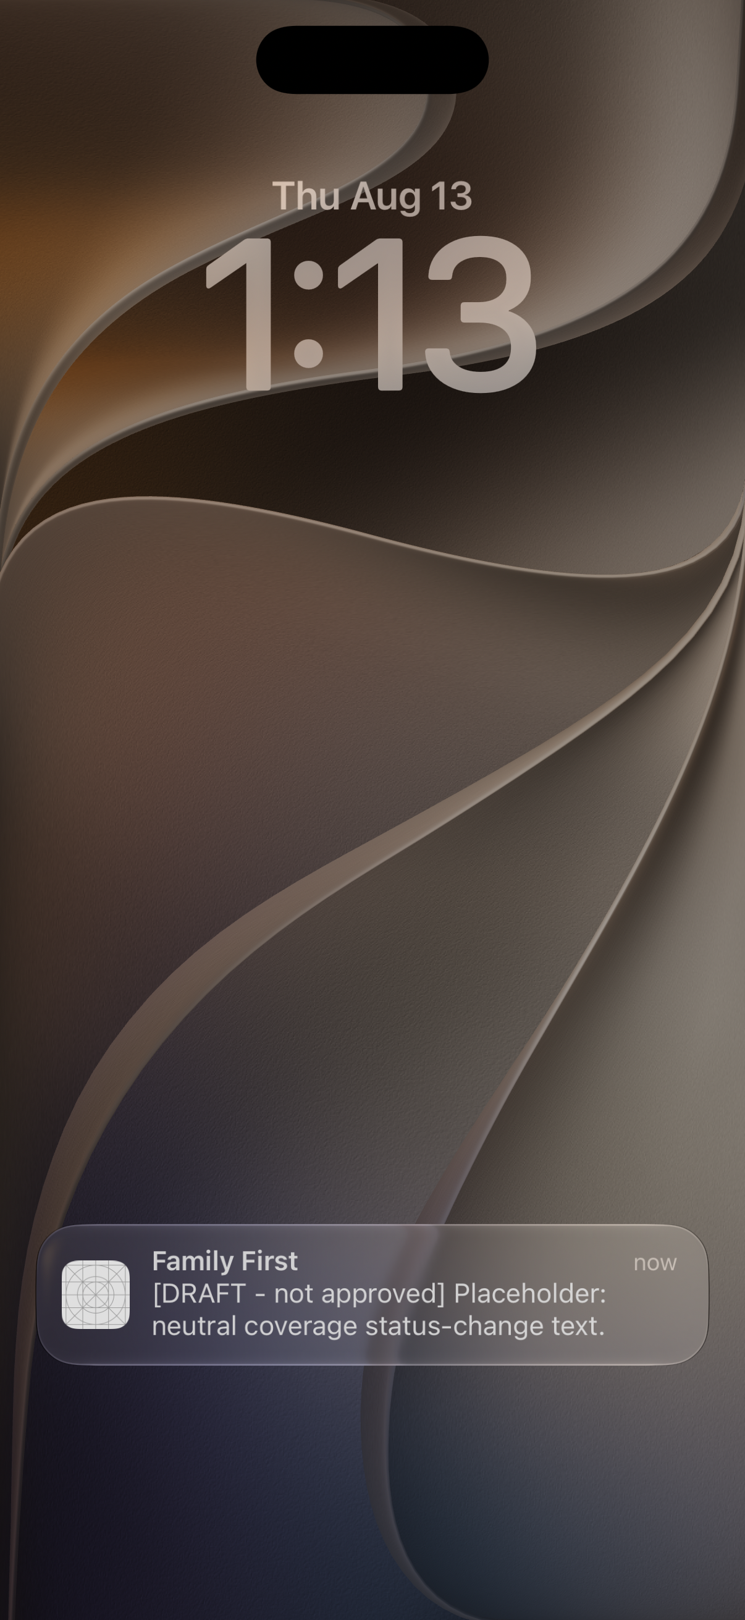
This lock-screen image was captured during the iPhone simulator run listed in the appendix. The message uses the draft fixed-copy catalog.
The alert contains no category, severity, preview, title, or subtitle. Automated testing inserted a sentinel into a sample event and confirmed that it was absent from every notification field.
Safety copy remains under review. The visible DRAFT label identifies wording awaiting safeguarding and legal approval. Final language cannot be promoted until those owners approve it.
Current delivery boundary. Alerts remain on the originating device. The prototype has no network or push-delivery capability. Guardian delivery depends on an approved encryption and key-recovery design. The demonstration does not simulate delivery it cannot perform.

3. Separation of research AI from safety decisions
Apple's on-device AI is being evaluated as a research comparison tool for adult and synthetic testing. It cannot create alerts or change a safety outcome. Production builds exclude this research component.
SAFETY PRODUCT LANE: produces user-visible status and guidance
1. Device access  Capability may be unavailable | 2. On-device analysis  Analysis may be unavailable | 3. Safety decision  Returns status unknown | 4. Guidance and local alerts  Three status alerts demonstrated
▲ Separation boundary. Automated source and production-build checks prevent the research model from reaching safety decisions or alerts.
RESEARCH MEASUREMENT LANE: adult and synthetic testing only; excluded from production
Apple's on-device model receives counts and timing values and returns three numeric buckets.
Observed: 20 calls; median 1.01 seconds; 20 of 20 matched the required structure.

Automated checks enforce the separation in source code and in the production build:
- Source-code checks confirm that the research component cannot reference alerts or safety decisions, no unrelated screen can import it, and production builds exclude it.
- Production-build checks confirm that the research model framework and related symbols are absent. A control marker confirms that the inspection ran.
Challenge test. Four prohibited connections were inserted during verification, and all four were detected. The original source was restored, and verification passed.

4. What the performance tests show
Measurement boundary. The current figures show how quickly the prototype executes on a Mac or simulator. They do not measure detection accuracy, iPhone battery use, heat, or endurance. Physical-device testing remains required.

4.1 Apple on-device AI research measurement
Twenty calls were measured under consistent test conditions. The first three warm-up calls were excluded, and model startup time was measured separately.
Measure | Observed result | Interpretation
Typical response | 1.01 seconds | Median of 20 structured test calls
90% of responses | 1.07 seconds or faster | Observed p90
95% of responses | 1.11 seconds or faster | Observed p95
Observed range | 0.93 to 1.11 seconds | Fastest to slowest measured call
Model startup | 0.12 seconds | Measured separately from the 20 calls
Response-format success | 100% | 20 of 20 matched the required structure
Failures | 0 | No failed calls in this test

Result formatting. All 20 responses used the required three-number structure and stayed within allowed ranges. This confirms reliable formatting for the test. It does not establish safety accuracy.

4.2 Image-processing options
Each of six technical configurations was measured across 200 test runs on an M3 Pro Mac. The results support relative architecture choices. Physical iPhone performance remains unmeasured.
Tested option | Model step | Image preparation | Combined
MobileNet V3 Small · Neural Engine | 0.32 ms | 7.14 ms | 7.55 ms
MobileNet V3 Large · Neural Engine | 0.57 ms | 8.84 ms | 9.87 ms
MobileViT XS · Neural Engine | 1.26 ms | 9.33 ms | 10.84 ms
EfficientNet Lite0 · Neural Engine | 0.54 ms | 10.17 ms | 10.87 ms
ViT Tiny · Neural Engine | 4.03 ms | 7.51 ms | 14.14 ms
MobileViT XS · CPU fallback | 5.53 ms | 9.33 ms | 15.81 ms

Observed result. Image preparation used more time than the model step in every measured configuration. The fastest test spent 7.14 ms on preparation and 0.32 ms on the model. Full screen-capture cost remains unmeasured because the required Apple permission is unavailable.

4.3 End-to-end safety flow
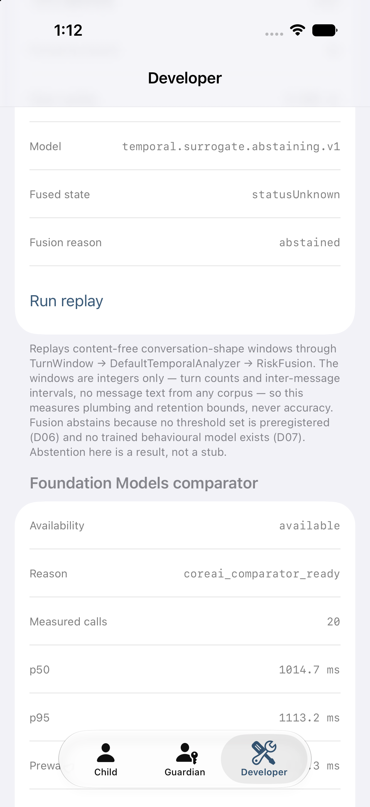
The upper panel shows the safety pipeline reaching “status unknown.” The lower panel shows the separate research model’s measured response time.
The safety pipeline processed 200 test windows containing 1,561 simulated conversation turns. It removed 16 older turns when the memory limit was reached and returned “status unknown.”
Safe default. The result was calculated during execution. Decision thresholds and trained category models remain pending, so no safety state is assigned.
The test used counts and timing values only. It contained no message text or training corpus because dataset authorization is pending.

5. Verification snapshot
Verification area | Observed result
Automated tests | 142 of 142 passed
Specification and privacy checks | 20 of 20 passed
Boundary challenge test | 4 of 4 prohibited connections detected
Production-build inspection | Research-model framework and symbols absent
Prototype builds | Debug and Release builds succeeded

Evidence status. Every result in this briefing comes from a Mac-hosted simulator or host-compute test. Product readiness is not claimed. Battery, heat, endurance, and end-to-end performance require physical iPhone testing.

6. Documented dependencies
The table records six dependencies, the capabilities they affect, and the assigned owner.
Dependency | Capability affected | Assigned owner
Final safety language | Approved child and guardian wording; removal of DRAFT labels | Safeguarding, legal, and child-safety reviewers
Evaluation thresholds | Approved mapping from measured scores to safety states | Evaluation working group
Authorized dataset | Training and evaluation of category models | Data governance
Encryption and recovery design | End-to-end encrypted guardian delivery | Security architecture
Provider permissions | Provider connections using approved scopes and flows | Partnerships
Physical iPhones | Battery, heat, endurance, performance, and device evidence | Program management

Current prototype status. The documented evidence covers the core processing flow, three local alerts, research-AI isolation, and reproducible automated checks. Detection quality, off-device guardian delivery, provider connectivity, and physical-device readiness remain unverified.

Appendix: Technical reproduction details
Environment. Xcode 27.0, iOS 27.0 SDK, iPhone 17 Pro simulator on iOS 27.0, and an Apple M3 Pro host running macOS 27.0. Apple Intelligence was enabled on the host.
Run identifier. 20260813T170928Z-4daffe26
The supporting screenshot and latency files are stored with the source materials, and their SHA-256 hashes are recorded in MANIFEST.json. The Guardian roster and event-detail screens are excluded because they contain synthetic fixture addresses or fixture content.
Reproduction commands:
make build-apple
make test-apple-unit
make verify-specs
make verify-coreai-isolation

